International Correspondence Chess Federation

Congress 2013

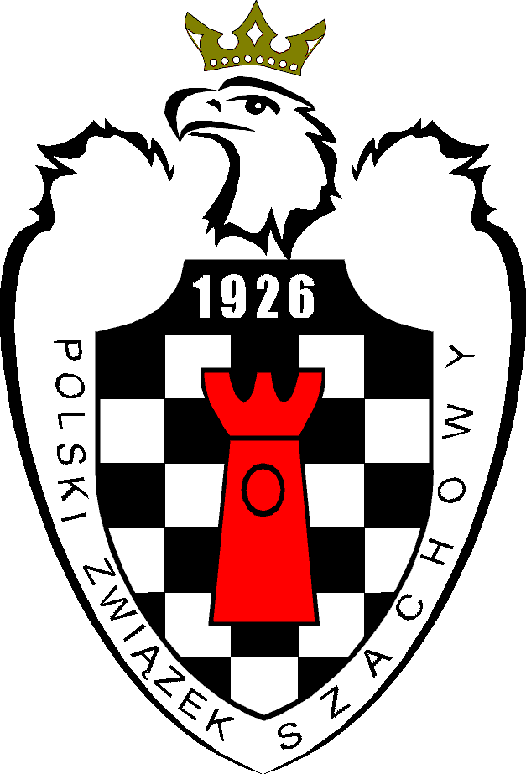
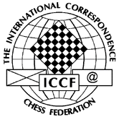

INFORMATION & RESERVATION DETAILS

Kraków – POLAND

20-27 July 2013

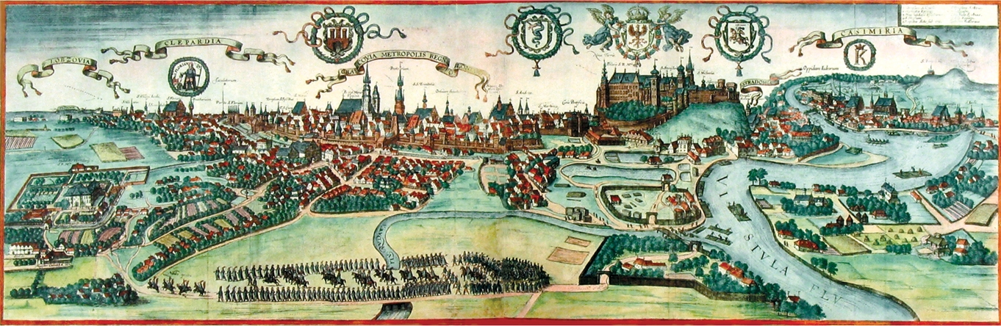
Kraków in 1603

1. INVITATION

The Polish Chess Federation has the honour to invite all ICCF Member Chess Federations around the world to participate in the ICCF Congress 2013 to be held in Kraków, Poland, in the period of 20-27 July 2013.

We would be delighted if you could join us to celebrate the 80th anniversary of the Polish CC Federation.

We hope to organize an excellent event with your participation.

The official congress website (http://kszgk.com/iccfcongress2013/) contains information that is more detailed and will be updated on regular basis.
2. REGISTRATION AND TRAVEL

2.1 The deadline for registration is 30 June 2013. However, accommodations are limited, so the sooner you register, the better. We are also offering incentives for early registration. The expression "participant" refers to Head of delegation, ICCF delegate, ICCF official or accompanying person.

2.2 The registration form must include: (a) name of federation, (b) surname, (c) first name, and (d) passport details of every person. It must also include head of delegation name and other details like phone number/ address/ fax / e-mail address. An identifying photo is required. If possible, please send a photo (preferable jpg format) of each participant with the registration. We will have provisions at the hotel to have your photo taken, but there may be a slight delay in hotel processing if you wait until arrival.

2.3 Congress participants arriving in Poland will be supported by volunteers at the Kraków Airport, Kraków Główny Railway Station, and possibly at the Warszawa Chopin Airport/ Katowice Airport. All travel expenses to and from the airport/ railway, or bus station must be paid by participants or their federations. Transportation from/to Kraków Airport or Kraków Główny railway/bus station is optional and can be provided by the host on request. Payment will be collected after arrival, if applicable. Possible means of transportation and estimated costs are presented at the congress website.

2.4 TRAVEL DETAILS.

The venue is the Hotel Park Inn by Radisson in Kraków, Poland.

Address: Park Inn Krakow, ul. Monte Cassino 2, 30-337 Krakow, Poland.

GPS Coordinates: N: 50° 2′ 51″; E: 19° 55′ 48″

Travelling by airplane

Kraków Airport is your main destination.

The venue is 11 km east of Kraków Airport (IATA code: KRK) called:

English: John Paul II International Airport Kraków-Balice

Polish: Międzynarodowy Port Lotniczy im. Jana Pawła II Kraków-Balice

Kraków is a very well known tourism city, and has a large number of regular/ charter flights main airports and many other smaller airports throughout Europe. Another way to arrive at Kraków Airport transferring through Warszawa Fryderyk Chopin Airport (IATA code: WAW).

Ground transportation from/to the airport – urban rail, buses, private car, or taxi.

As mentioned earlier, Warszawa Fryderyk Chopin Airport (IATA code: WAW) with transfer to Kraków by train or domestic flight is good option as well.

Other airports might be considered by participants, but it is much less convenient solution, because of some logistics challenges. Potential airports to be taken into account:

Warsaw-Modlin Mazovia Airport (IATA code: WMI) is located 40 kilometers to the north of the city centre of Warsaw. It is operated by Ryanair and WizzAir.

Katowice International Airport (IATA code: KTW) is an international airport, located in Pyrzowice, 30 km north of centre of Katowice.

Travelling by train
Kraków Główny (Kraków Main) railway station is your main destination.
Rail connections are available from/to most Polish cities. Trains from Warszawa to Kraków depart every hour.
International destinations include Berlin, Budapest, Prague, Hamburg, Lvov, Kiev, and Odessa (June–September). The main railway station is located just outside the Old Town District and is well served by public transport.

Travelling by bus
Kraków Regional Bus Station is your main destination. It is located next to Kraków Główny railway station.
International connections include (among many others) Amsterdam, Antwerpen, Berlin, Bern, Bonn, Brno, Bruxelles, Budapest, Dortmund, Dresden, Dusseldorf, Geneve, Hamburg, Luxembourg, Luzern, Monaco, Munchen, Olomouc, Ostrava, Paris, Praha, Sofia, Thessaloniki, Utrecht, Wien, Zurich.

For more details, see the congress website under page "Travel".

3. PAYMENT
3.1 BANK TRANSFER. When registering, payment for booked accommodation (details in the table below under paragraph 4) must be transferred to the following account of the organizer:
Account details:
Bank Name: ING O/Kielce
Account Holder: Świętokrzyski Związek Szachowy
IBAN: PL05 1050 1416 1000 0090 8000 4816
SWIFT/BIC: INGBPLPW
Please use IBAN without spaces between numbers. All bank commissions are to be paid by sender.
3.2 OPTIONAL METHODS OF PAYMENT. After 15 February 2013, other methods of payment (e.g. by credit card or by PayPal, etc) might be possible, if requested. To be discussed with the organizer.
3.3 CONFIRMATION. As soon as payment transfer is confirmed, the organizing committee will send to applicant the confirmation of the hotel reservations. In addition, all confirmed registrations would be placed on the official website on page "Participants", where participants may verify their registration status.

4. ACCOMMODATION
4.1 Accommodation is offered in the Hotel Park Inn by Radisson in Kraków (4 stars hotel) booked in advance by the organizing committee.
4.2 The organizer offers special discount if the accommodation charges are paid in advance. The payment must be in Euros (€).

1 | Accommodation: | Hotel Park Inn by Radisson (4*)
2 | Room type: | Single Room (one person): | Double Room (two persons):
3 | Key features: | Buffet breakfast included  Complimentary access to fitness centre and sauna.  Massage services available by appointment (not included in the price).  Free high-speed, wireless Internet access.  Other services like mini bar, pay TV, etc. not included in the price.
4 | Smoking/ handicap and other preferences: | Non-smoking rooms and handicap-accessible rooms or other preferences are available upon request. To be discussed with organizer at the time of registration.
5 | Advance payment until 20.05.2013 with special discount: | 75 € per night, per room | 105 € per night, per room
 |  | Buffet breakfast included
 |  | Lunch: 20 € per person per day
 |  | Supper: 20 € per person per day
6 | Extra bed: | 35 € per night (breakfast included)  One child under 2 years stays free of charge in a child's cot/crib. The maximum number of extra beds/children's cots permitted in a room is 1. Any type of extra bed or child's cot/crib is upon request and needs to be confirmed.
7 | Additional special discount: | Organizer offers additional special discount to rates above [5, 6]:  - 5% - if paid until 20.04.2013  - 10% - if paid until 20.03.2013  - 10% - if deposit 150 Euros/person paid until 25.02.2013 and the rest until 15.05.2013
9 | Cancelation: | Special discount if you are certain to come. Any cancellation or reservation changes: no refunds at all. The total price of the reservation to be paid on the day of booking.
10 | Late payment/ booking (after 20.05.2013): | Without guarantee of special rates. Rooms will be booked on the principle of FCFS (First Come First Served).
11 | Payment: | Transfer to the organizer bank account:  Account details:  Bank Name: ING O/Kielce  Account Holder: Świętokrzyski Związek Szachowy  IBAN: PL05 1050 1416 1000 0090 8000 4816  SWIFT/BIC: INGBPLPW  Please use IBAN without spaces between numbers. All bank commissions are to be paid by sender.
12 | Optional methods of payment: | After 15.02.2013 other methods of payment (e.g., by credit card or e-payment) might be possible, if requested. To be discussed with organizer.
13 | Invoice (in EUR): | To be presented by the organizer after arrival. However, it might be provided earlier upon request. To be discussed with organizer.
14 | Parking: | 5 PLN/h or 50 PLN/day - paid separately by participants to the hotel
15 | Taxes: | VAT and applicable taxes included.  Additional taxes and surcharges may apply.

5. INFORMATION ABOUT VISAS
5.1 Please check the following links for visa and other information:
- Entering Poland
- Visa-free countries
- Entry conditions for third-country nationals under visa obligation
- Information on limits in travelling to Poland from third countries
5.2 Federations or participants who need assistance with their visas are asked to contact the Organizing Committee at their convenience, but the best before 01 March 2013.
5.3 Director of the Organizing Committee will supply official letters of invitation, if requested by participant.
6. CLIMATE
Kraków has an Oceanic climate. The city features a temperate climatic zone. Average temperatures in summer range from 18 °C to 20 °C. In summer, temperatures often, exceed 25 °C, and sometimes even exceed 30 °C. In view of the fact that Kraków lies near the Tatra Mountains, there is often blowing halny – a foehn wind, when the temperature rises rapidly, and even in winter reaches to 20 °C.
However, rain showers may occur during this time.
7. ELECTRICITY
Main voltage is 230V, which means that any appliance that works in the UK will work in Poland. Plugs are the standard European two-pin type rather than the UK three pin versions.
8. CONTACT INFORMATION

The Organizing Committee
Function | Name | Polish CC Federation Role | E-mail address | Phone
Director | Tomasz Stefaniak | President | tstefaniak@stamp.com.pl | +48 507-013-391
Event Organizer | Barbara Juszkiewicz |  | ester@strusiowo.pl | +48 602-425-181
Member | Mariusz Wojnar | ICCF Delegate | mariusz.wojnar@gmail.com | +48 513-997-101
Please be advised that we are not native English speakers. Persons able to be communicative in English (to some extent) are Mrs Barbara Juszkiewicz and Mr Mariusz Wojnar.
The main point of contact is Event Organizer - Mrs Barbara Juszkiewicz.

